NGO DONATION AND VOLUNTEER MANAGEMENT
A PROJECT REPORT
Submitted by
RAKSHITHA RD
(2116241501163)
in partial fulfilment of the End Semester Examination for the course
CB23F35 –
LOW-CODE APPLICATION DEVELOPMENT USING ZOHO CREATOR
in
BACHELOR OF TECHNOLOGY
ARTIFICIAL INTELLIGENCE AND MACHINE LEARNING

RAJALAKSHMI ENGINEERING COLLEGE
(An Autonomous Institution, Affiliated to Anna University, Chennai)
Rajalakshmi Nagar, Thandalam, Tamil Nadu – 602 105
OCTOBER 2026

RAJALAKSHMI ENGINEERING COLLEGE
(An Autonomous Institution, Affiliated to Anna University, Chennai)
BONAFIDE CERTIFICATE
Certified that this project report titled “NGO Donation and Volunteer Management” is the bonafide work of Rakshitha RD (2116241501163), who carried out the individual project work on Zoho Creator for the course CB23F35 – Low-Code Application Development using Zoho Creator, during the academic year 2026–2027, Semester V, under my supervision.
SIGNATURE  Dr. M. Ayyadurai  HEAD OF THE DEPARTMENT  Department of Artificial Intelligence and Machine Learning  Rajalakshmi Engineering College  Thandalam – 602 105 | SIGNATURE  Priya, M. E.  COURSE FACULTY  Assistant Professor  Department of Artificial Intelligence and Machine Learning  Rajalakshmi Engineering College

Submitted for the End Semester Examination held on ____________________.
INTERNAL EXAMINER | EXTERNAL EXAMINER
DECLARATION
I, Rakshitha RD (2116241501163), declare that this report titled “NGO Donation and Volunteer Management” documents the application in my Zoho Creator account for CB23F35 – Low-Code Application Development using Zoho Creator. It describes the application design, observed outputs and verification work.
The application was created using the project’s Zoho Creator CLI with AI-assisted development. AI assistance and Playwright were also used for report preparation and browser evidence. These contributions are acknowledged. I am responsible for reviewing the report, understanding the implementation and demonstrating the application.
Place: Chennai SIGNATURE OF THE STUDENT
Date: ____________________ Rakshitha RD
2116241501163
ACKNOWLEDGEMENT
I thank the management of Rajalakshmi Engineering College for the facilities and learning environment provided for this project.
I thank the Principal of Rajalakshmi Engineering College for supporting practical learning and application development.
I thank Dr. M. Ayyadurai, Head of the Department of Artificial Intelligence and Machine Learning, for the academic support provided during the course.
I thank Priya, M. E., Assistant Professor and course faculty, for guidance on the course and project requirements.
I acknowledge Zoho Corporation for Creator and its documentation, and the project’s CLI, AI assistance and Playwright for development and report preparation. I also thank my family and friends for their support.

Rakshitha RD

ABSTRACT
NGO Donation and Volunteer Management is a Zoho Creator application for tracking fundraising and volunteer participation. Small NGOs often keep donor details, payment records and volunteer assignments in separate spreadsheets, making verification and follow-up difficult. The application connects five forms: Campaigns, Donors, Donations, Volunteers and Events. Lookup fields associate donations with donors and campaigns, while the Volunteer Assignments subform is designed to record event duties, attendance and hours. The local implementation defines sixteen form workflows, three reusable Deluge functions and one daily schedule. These scripts cover date and duplicate checks, payment references, donation decisions, campaign totals, donor levels and volunteer-hour calculations. Twelve reports provide nine list views, two summary views and an event Kanban board. One dashboard combines six indicators, four charts, four action buttons and two embedded reports. Administrator, Coordinator and Volunteer profiles define operational responsibilities. The application was inspected in an authenticated Chrome session on 20 October 2026. Its visible records comprised ten campaigns, twelve donors, twenty-two donations and twelve volunteers. Seventeen verified donations totalled INR 867500; four donations awaited verification and one was rejected. Four campaigns and eleven volunteers were active. The Events report contained no records, so event participation and beneficiary outcomes were not demonstrated. Source-defined notification, schedule and access rules were reviewed without claiming successful email delivery or separate-role testing. The project demonstrates a connected low-code solution for donation oversight and volunteer coordination, with the remaining event, role and workflow tests identified for completion.
Keywords: Zoho Creator; Deluge; NGO Management; Donation Verification; Volunteer Coordination

PROJECT AT A GLANCE
Attribute | Details
Project Title | NGO Donation and Volunteer Management
Domain | NGO fundraising and volunteer coordination
Student | Rakshitha RD — 2116241501163
Creator Edition | Expired trial notice observed
Application Link Name | ngo-donation-and-volunteer-management
Authenticated Live URL | https://creatorapp.zoho.in/rakshitha.rd.2024.aiml_ra898/ngo-donation-and-volunteer-management
Demo Access | Assigned Zoho accounts; credentials excluded
Forms / Subforms | 5 / 1 Volunteer Assignments
Reports | 9 List / 2 Summary / 1 Kanban
Pages | 1 Dashboard: 6 indicators, 4 charts, 4 buttons, 2 reports
Workflows | 16 form workflows / 1 daily schedule in source
Functions | 3 reusable Deluge functions
Integration | External CLI API tooling; scripted email
Access Profiles | Administrator, Coordinator, Volunteer
Environments | Live app inspected; promotion not verified
Verification Date | 20 October 2026
Visible Dataset | 10 campaigns; 12 donors; 22 donations; 12 volunteers; 0 events
TABLE OF CONTENTS
ABSTRACT iv
PROJECT AT A GLANCE v
LIST OF TABLES ix
LIST OF FIGURES x
LIST OF ABBREVIATIONS xi
INTRODUCTION 1
1.1 Background 1
1.2 Problem Statement 1
1.3 Objectives 1
1.4 Scope of the Project 1
1.5 Justification for a Low-Code Approach 2
1.6 Organisation of the Report 2
LITERATURE SURVEY AND SYSTEM STUDY 3
2.1 Study of the Existing System 3
2.2 Limitations of the Existing System 3
2.3 Low-Code versus Traditional Development 3
2.4 Literature Survey 4
2.5 Emerging Trends in Low-Code Development 4
2.6 Proposed System 4
REQUIREMENT ANALYSIS 5
3.1 Stakeholders and User Roles 5
3.2 Functional Requirements 5
3.3 Non-Functional Requirements 5
3.4 Hardware and Software Requirements 6
3.5 Use Case Model 6
SYSTEM DESIGN 8
4.1 System Architecture 8
4.2 Data Model 8
4.3 Form Design 9
4.4 Process and Workflow Design 12
4.5 User Interface and Navigation Design 12
4.6 Access Control Design 13
IMPLEMENTATION 14
5.1 Application Setup 14
5.2 Forms and Data Capture 14
5.3 Reports 17
5.4 Pages and Dashboards 19
5.5 Deluge Scripting 19
5.6 Workflows and Automation 20
5.7 Integrations 21
5.8 User Management and Role-Based Access 22
5.9 AI and Analytics Features 22
5.10 Pro-Code Extension 22
5.11 Mobile and Portal Access 22
TESTING AND DEBUGGING 23
6.1 Testing Strategy 23
6.2 Test Cases 23
6.3 Debugging Deluge Scripts 24
6.4 Defect Log 24
6.5 User Acceptance Testing 25
DEPLOYMENT, SECURITY AND GOVERNANCE 26
7.1 Environments and Deployment Strategy 26
7.2 Performance Optimisation 26
7.3 Security Features 27
7.4 Governance and Administration 27
RESULTS AND DISCUSSION 28
8.1 Application Output 28
8.2 Achievement of Objectives 30
8.3 Comparison with the Existing System 30
8.4 Limitations of the Low-Code Approach 30
8.5 Reflection on the No-Code → Low-Code → Pro-Code Spectrum 30
CONCLUSION AND FUTURE ENHANCEMENTS 32
9.1 Conclusion 32
9.2 Future Enhancements 32
9.3 Learning Outcomes and Career Relevance 32
REFERENCES 33
APPENDIX A – ZOHO CREATOR FEATURE COVERAGE CHECKLIST 34
APPENDIX B – COURSE OUTCOME MAPPING 37
APPENDIX C DELUGE SOURCE ROUTINES 38
APPENDIX D – USER MANUAL 40
D.1 Accessing the Application 40
D.2 Administrator and Coordinator 40
D.3 Volunteer and Event Operations 40
APPENDIX E – EVALUATION RUBRIC 41
APPENDIX F – VIVA-VOCE RECORD SHEET 43

LIST OF TABLES
Table 2.1: Comparison of Low-Code and Traditional Development for the Proposed Application 3
Table 2.2: Summary of Literature Survey 4
Table 3.1: Stakeholders and User Roles 5
Table 3.2: Functional Requirements 5
Table 3.3: Non-Functional Requirements 5
Table 3.4: Hardware and Software Requirements 6
Table 3.5: Donation Verification Use Case 6
Table 4.1: Entities and Relationships 9
Table 4.2: Campaigns Field Specification 9
Table 4.3: Donors Field Specification 9
Table 4.4: Donations Field Specification 10
Table 4.5: Volunteers Field Specification 11
Table 4.6: Events Field Specification 11
Table 4.7: Volunteer Assignments Subform 12
Table 4.8: Source Defined Permission Matrix 13
Table 5.1: Reports Implemented 17
Table 5.2: Deluge Scripts Implemented 19
Table 5.3: Workflows Implemented 20
Table 5.4: Integrations Implemented 21
Table 6.1: Test Cases 23
Table 6.2: Defect Log 24
Table 6.3: User Acceptance Feedback 25
Table 7.1: Deployment Checklist 26
Table 7.2: Performance Optimisation Results 27
Table 7.3: Security Controls Implemented 27
Table 8.1: Mapping of Objectives to Outcomes 30
Table 8.2: Existing System versus Proposed Application 30
Table A.1: Feature Coverage Checklist 34
Table B.1: Mapping of Course Outcomes to Report Chapters 37
Table E.1: Evaluation Rubric for the Individual Project 41
Table E.2: Performance Level Descriptors 42
Table F.1: Viva-Voce Questions and Responses 43
Table F.2: Marks Summary 43

LIST OF FIGURES
Figure 2.1: Illustrative Manual NGO Process 3
Figure 3.1: NGO Management Use Cases 6
Figure 4.1: System Architecture 8
Figure 4.2: NGO Data Relationships 8
Figure 4.3: Donation Verification and Volunteer Flow 12
Figure 4.4: Application Navigation 13
Figure 5.1: Live Navigation and Campaign Records 14
Figure 5.2: Campaigns Form in Live Mode 15
Figure 5.3: Donations Form in Live Mode 15
Figure 5.4: Donors Form in Live Mode 16
Figure 5.5: Volunteers Form in Live Mode 16
Figure 5.6: Events Form in Live Mode 17
Figure 5.7: Event Board with No Current Records 18
Figure 5.8: Live Donation and Volunteer Dashboard 19
Figure 8.1: Donation Records and Current Statuses 28
Figure 8.2: Treasurer Queue with Four Pending Donations 29
Figure 8.3: Volunteer Register with Twelve Records 29

LIST OF ABBREVIATIONS
Abbreviation | Expansion
API | Application Programming Interface
CLI | Command Line Interface
ER | Entity Relationship
FR | Functional Requirement
INR | Indian Rupee
NGO | Non Governmental Organisation
OAuth | Open Authorization
PAN | Permanent Account Number
RBAC | Role Based Access Control
REST | Representational State Transfer
UAT | User Acceptance Testing
UPI | Unified Payments Interface

CHAPTER 1

INTRODUCTION

1.1 Background
The application models the work of a small NGO that runs fundraising campaigns and community events. The administrator verifies donations, coordinators maintain operational records, and volunteers register and view relevant activities. The demonstration uses sample data rather than records of a named operating NGO.

1.2 Problem Statement
An NGO needs a consistent record of donors, verified funds and volunteer activity. Separate spreadsheets and messages make it difficult to reconcile campaign collections, locate pending payments and account for participation.
- Donor and campaign details are repeated across donation records.
- Unverified payments may be confused with available campaign funds.
- Volunteer assignments, attendance and hours lack a shared record.

1.3 Objectives
- Maintain five related forms with reusable donor, campaign and volunteer lookups.
- Validate dates, payment references, duplicates and event assignments.
- Provide twelve operational reports and one dashboard.
- Define automated campaign totals, donor levels, volunteer hours and notifications.
- Separate administrator, coordinator and volunteer access through profiles and report criteria.

1.4 Scope of the Project
The scope covers browser forms, donation verification, campaign progress, volunteer registration, event assignments, reports and charts. Payment-gateway collection, external accounting integration, mobile demonstrations and customer portals are outside the verified implementation.

1.5 Justification for a Low-Code Approach
These processes fit related forms, criteria-based reports and event-driven scripts. Creator supplies the platform components [1], while Deluge expresses the NGO-specific rules. The CLI retains readable application definitions. Development-time or cost savings were not measured.

1.6 Organisation of the Report
Chapters 2–4 cover the system study, requirements and design. Chapter 5 explains implementation. Chapters 6–8 present verification, deployment and results. Chapter 9 concludes the report; the appendices contain coverage, selected source routines and operating instructions.
CHAPTER 2

LITERATURE SURVEY AND SYSTEM STUDY

2.1 Study of the Existing System
In the illustrative manual process, staff collect donor details, record payments in a spreadsheet, ask the treasurer to check them, and coordinate volunteers through messages. Campaign totals and attendance summaries are compiled separately. This is a process baseline, not a measured survey.

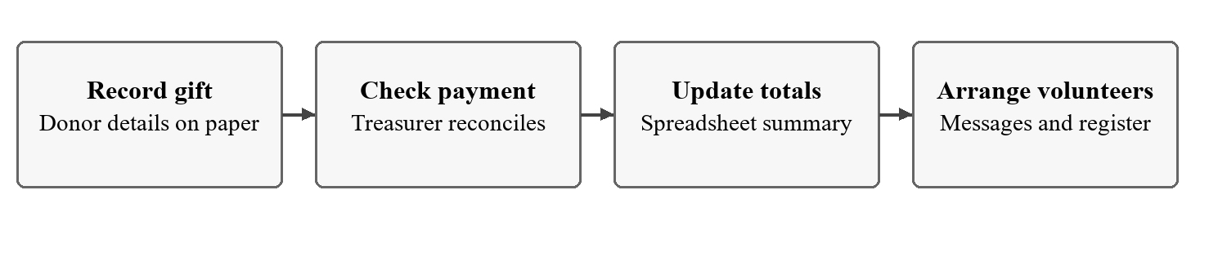
Figure 2.1: Illustrative Manual NGO Process

2.2 Limitations of the Existing System
- Repeated entry makes donor and campaign details harder to maintain.
- Separate payment lists obscure pending verification and campaign balances.
- Volunteer messages do not provide structured attendance and hour totals.

2.3 Low-Code versus Traditional Development
Table 2.1: Comparison of Low-Code and Traditional Development for the Proposed Application
Criterion | Traditional Development | Zoho Creator
Implementation | Build forms, database and server | Configure forms, reports and Deluge
Skills | Application and database programming | Data modelling and Deluge
Hosting | Provision application infrastructure | Creator-hosted application
Access | Implement authorisation | Profiles and record criteria
Maintenance | Coordinate schema and source changes | Version YAML and Deluge
Effort and cost | No comparative baseline recorded | No measured saving claimed

2.4 Literature Survey
Table 2.2: Summary of Literature Survey
No. | Source | Topic | Finding | Use in this project
1 | Zoho [1] | Creator features | Related platform components | Forms, reports and charts
2 | Zoho [2] | Subform | Multiple child rows per record | Event assignments
3 | Zoho [3] | Record fetch | Criteria select matching data | Verified totals and checks
4 | Zoho [4] | Send mail | Scripted notifications | Receipt and reminder rules
5 | Zoho [5] | Creator API | Authenticated application access | External CLI tooling

2.5 Emerging Trends in Low-Code Development
AI-assisted development and readable application definitions helped structure the initial solution. Generated scripts still need review and runtime tests. The live application does not use a Zia prediction, OCR or machine-learning field.

2.6 Proposed System
The proposed system links each donation to a donor and campaign, distinguishes pending, verified and rejected payments, and presents operational reports. Events link campaigns to volunteer-assignment rows. The dashboard summarises funds and activity from stored records.
CHAPTER 3

REQUIREMENT ANALYSIS

3.1 Stakeholders and User Roles
Table 3.1: Stakeholders and User Roles
Role | Description | Responsibilities
Administrator | Owner and treasurer | Verify payments; full data and user control
Coordinator | NGO staff | Maintain campaigns, donors, volunteers and events
Volunteer | Registered participant | Register and view permitted activities and own profile

3.2 Functional Requirements
Table 3.2: Functional Requirements
FR ID | Requirement | Role | Priority
FR-01 | Maintain campaigns and donor records | Coordinator | High
FR-02 | Record linked donations and validate payment data | Coordinator | High
FR-03 | Verify or reject donations and recount verified totals | Administrator | High
FR-04 | Register volunteers with skills and availability | Volunteer / Coordinator | High
FR-05 | Assign volunteers and record attendance and hours | Coordinator | High
FR-06 | Provide filtered reports and dashboard charts | Permitted roles | High
FR-07 | Define receipts, reminders and daily status updates | Administrator | Medium
FR-08 | Restrict module actions and own-profile access | All roles | High

3.3 Non-Functional Requirements
Table 3.3: Non-Functional Requirements
NFR ID | Category | Requirement
NFR-01 | Performance | Usable reports; latency benchmark pending
NFR-02 | Security | Enforce profile actions and own-record criteria
NFR-03 | Usability | Clear fields and consistent browser navigation
NFR-04 | Availability | Authenticated hosted access with suitable account plan
NFR-05 | Maintainability | Readable versioned application definitions
NFR-06 | Auditability | Retain change, test and deployment evidence

3.4 Hardware and Software Requirements
Table 3.4: Hardware and Software Requirements
Category | Specification
Platform | Zoho Creator browser application
Business scripting | Deluge
Browser | Google Chrome used for inspection
Development tooling | TypeScript CLI and Playwright
API tooling | Creator API v2.1; OAuth in CLI
Mobile | Not tested
Hardware | Internet-connected computer with supported browser

3.5 Use Case Model

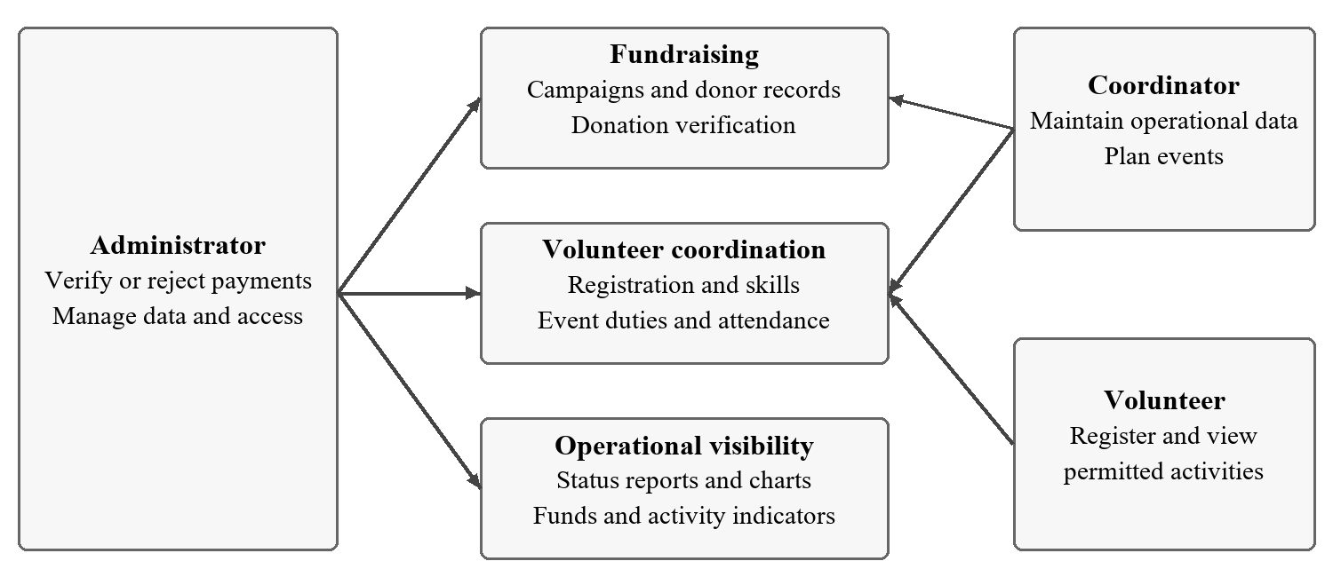
Figure 3.1: NGO Management Use Cases
Table 3.5: Donation Verification Use Case
Use Case ID | UC-01
Name | Verify a donation
Actors | Coordinator; Administrator
Precondition | Donor and campaign exist; payment recorded
Main Flow | 1. Record payment. 2. Inspect reference and proof. 3. Verify. 4. Check totals.
Alternative | Reject with treasurer remarks
Postcondition | Verified amount contributes to donor and campaign totals
Related Requirements | FR-02, FR-03, FR-07
CHAPTER 4

SYSTEM DESIGN

4.1 System Architecture

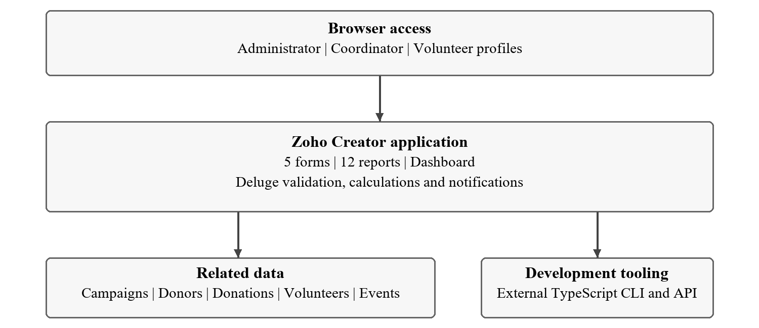
Figure 4.1: System Architecture
Users access Creator through a browser. Forms store related records; reports organise operational views; Deluge workflows define checks and updates. The external TypeScript CLI generates and imports the application. Source-defined sendmail tasks provide notifications; no external accounting connector is configured.

4.2 Data Model

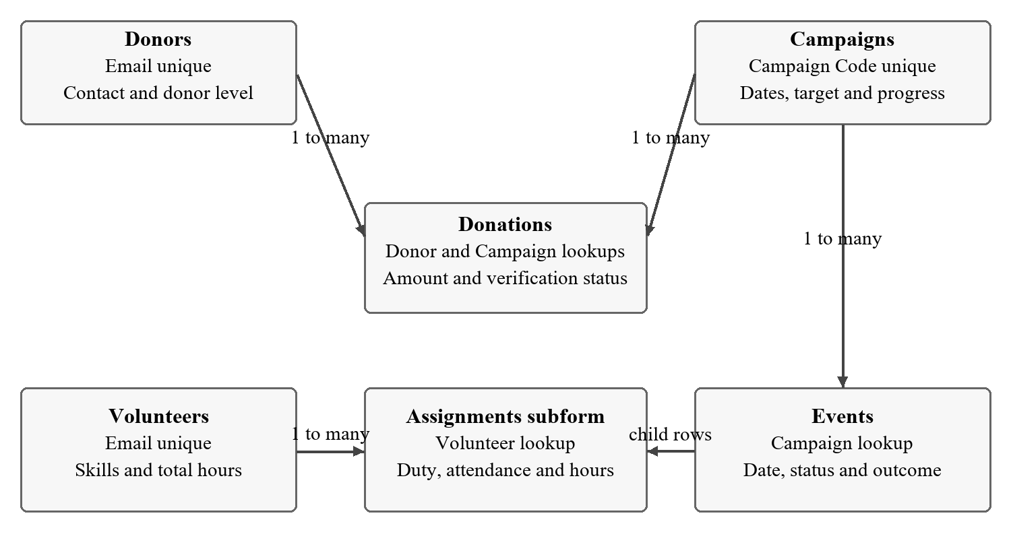
Figure 4.2: NGO Data Relationships
Table 4.1: Entities and Relationships
Entity | Key Fields | Related To | Relation | Mechanism
Campaigns | Campaign_Code | Donations; Events | One to many | Campaign lookup
Donors | Donor_Name; Email | Donations | One to many | Donor lookup
Events | Event_Code | Assignments | Parent child | Subform
Volunteers | Volunteer_Name; Email | Assignments | One to many | Volunteer lookup

4.3 Form Design
Table 4.2: Campaigns Field Specification
Field Label | Link Name | Type | Required | Rule or default | Purpose
Campaign Code | Campaign_​Code | Single Line | Yes | Unique
Campaign Name | Campaign_​Name | Single Line | Yes | Required
Cause | Cause | Drop Down | Yes | Required | Education, Healthcare, Food Relief, Environment, Disaster Relief, Women Empowerment
Start Date | Start_​Date | Date | Yes | Required
End Date | End_​Date | Date | Yes | Required
Target Amount | Target_​Amount | Currency | Yes | INR 1000 to 10000000
Amount Raised | Amount_​Raised | Currency | No | Script maintained
Progress (%) | Progress_​Percent | Decimal | No | Script maintained
Campaign Status | Campaign_​Status | Drop Down | Yes | Required | Planned, Active, Completed
Description | Description | Multi Line | No | Optional
Table 4.3: Donors Field Specification
Field Label | Link Name | Type | Required | Rule or default | Purpose
Donor or Organisation Name | Donor_​Name | Single Line | Yes | Required
Donor Type | Donor_​Type | Radio | Yes | Required | Individual, Corporate, Trust
Contact Person | Contact_​Person | Single Line | No | Optional
Email | Email | Email | Yes | Unique
Phone | Phone | Phone | Yes | Required
City | City | Single Line | Yes | Required
PAN (for 80G receipts) | PAN_​Number | Single Line | No | Optional
Total Donated | Total_​Donated | Currency | No | Script maintained
Donor Level | Donor_​Level | Drop Down | No | Script maintained | New, Supporter, Patron, Champion
Table 4.4: Donations Field Specification
Field Label | Link Name | Type | Required | Rule or default | Purpose
Receipt No | Receipt_​No | Auto Number | No | Optional
Donor | Donor | Lookup | Yes | Required | Lookup to Donors
Campaign | Campaign | Lookup | Yes | Required | Lookup to Campaigns
Donation Date | Donation_​Date | Date | Yes | Required
Amount | Amount | Currency | Yes | INR 1 to 1000000
Payment Mode | Payment_​Mode | Drop Down | Yes | Required | Cash, UPI, Bank Transfer, Cheque
Transaction or Cheque No | Transaction_​Ref | Single Line | No | Optional
Donor wants an 80G tax receipt | Claim_​80G | Decision Box | No | Optional
Payment Proof | Payment_​Proof | File Upload | No | Optional
Donation Status | Donation_​Status | Drop Down | Yes | Required | Pending Verification, Verified, Rejected
Treasurer Remarks | Treasurer_​Remarks | Multi Line | No | Optional
Table 4.5: Volunteers Field Specification
Field Label | Link Name | Type | Required | Rule or default | Purpose
Volunteer Name | Volunteer_​Name | Single Line | Yes | Required
Email | Email | Email | Yes | Unique
Phone | Phone | Phone | Yes | Required
Date of Birth | Date_​of_​Birth | Date | Yes | Required
City | City | Single Line | Yes | Required
Skills | Skills | Multi Select | Yes | Required | Teaching, Medical, Event Management, Fundraising, Logistics, Photography, IT Support
Availability | Availability | Radio | Yes | Required | Weekdays, Weekends, Both
ID Proof | ID_​Proof | File Upload | No | Optional
Hours Served | Total_​Hours | Number | No | Script maintained
Volunteer Status | Volunteer_​Status | Drop Down | Yes | Required | Active, Inactive
Table 4.6: Events Field Specification
Field Label | Link Name | Type | Required | Rule or default | Purpose
Event Code | Event_​Code | Single Line | Yes | Unique
Event Name | Event_​Name | Single Line | Yes | Required
Campaign | Campaign | Lookup | Yes | Required | Lookup to Campaigns
Event Date | Event_​Date | Date | Yes | Required
Location | Location | Single Line | Yes | Required
Volunteers Needed | Volunteers_​Needed | Number | Yes | Required
Volunteer Assignments | Assignments | Subform | No | Optional | Volunteer child rows
Total Volunteer Hours | Total_​Volunteer_​Hours | Number | No | Script maintained
Event Status | Event_​Status | Drop Down | Yes | Required | Scheduled, Completed, Cancelled
Beneficiaries Reached | Beneficiaries_​Reached | Number | No | Optional
Outcome and notes | Outcome_​Summary | Multi Line | No | Optional
Table 4.7: Volunteer Assignments Subform
Field Label | Link Name | Type | Required | Rule | Purpose
Volunteer | Volunteer | Lookup | Yes | Active; no duplicates | Select volunteer
Duty | Duty | Drop Down | Yes | Choose duty | Work assignment
Hours Served | Hours_Served | Number | No | 0 to 12 hours | Attendance total
Attendance | Attendance | Drop Down | Yes | Assigned / Present / Absent | Completion check

4.4 Process and Workflow Design

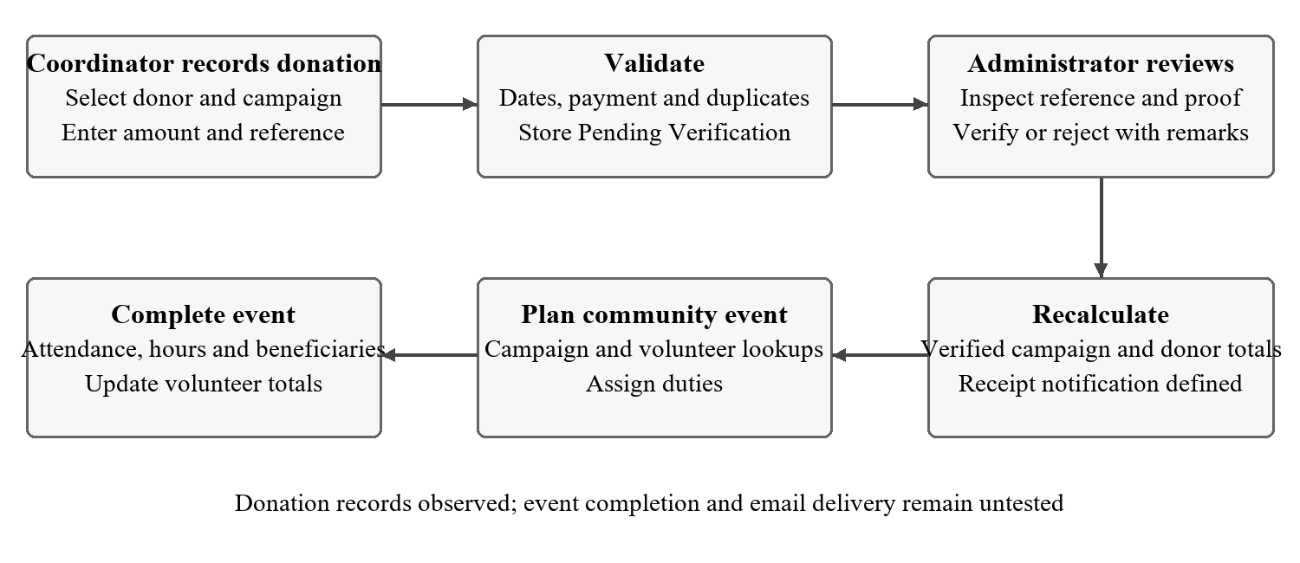
Figure 4.3: Donation Verification and Volunteer Flow

4.5 User Interface and Navigation Design

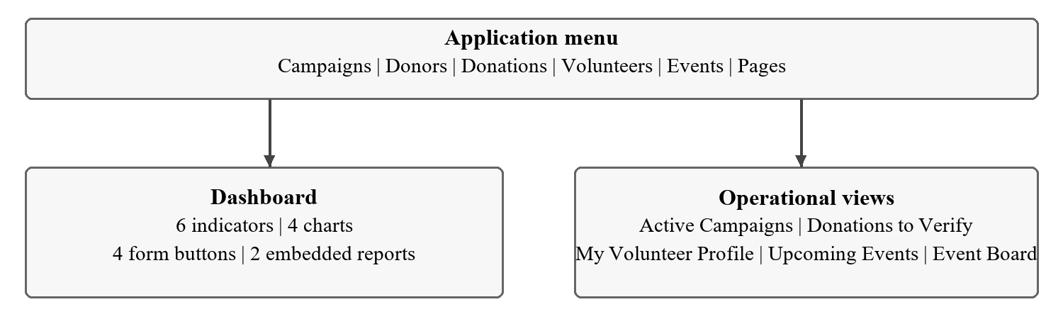
Figure 4.4: Application Navigation

4.6 Access Control Design
Table 4.8: Source Defined Permission Matrix
Component | Administrator | Coordinator | Volunteer | Record scope
Campaigns | A E V D | A E V | V | Active campaigns for Volunteer
Donors | A E V D | A E V | None | Staff only
Donations | A E V D | A V | None | Administrator decides
Volunteers | A E V D | A E V | A V | Own email for Volunteer
Events | A E V D | A E V | V | Upcoming for Volunteer
Dashboard | V | V | None | Staff overview
CHAPTER 5

IMPLEMENTATION

5.1 Application Setup
The application was generated from the repository’s YAML and Deluge definitions and imported through the CLI. The current live owner is rakshitha.rd.2024.aiml_ra898. The browser navigation contains Campaigns, Donors, Donations, Volunteers, Events and Pages. The account displayed an expired-trial notice during inspection.

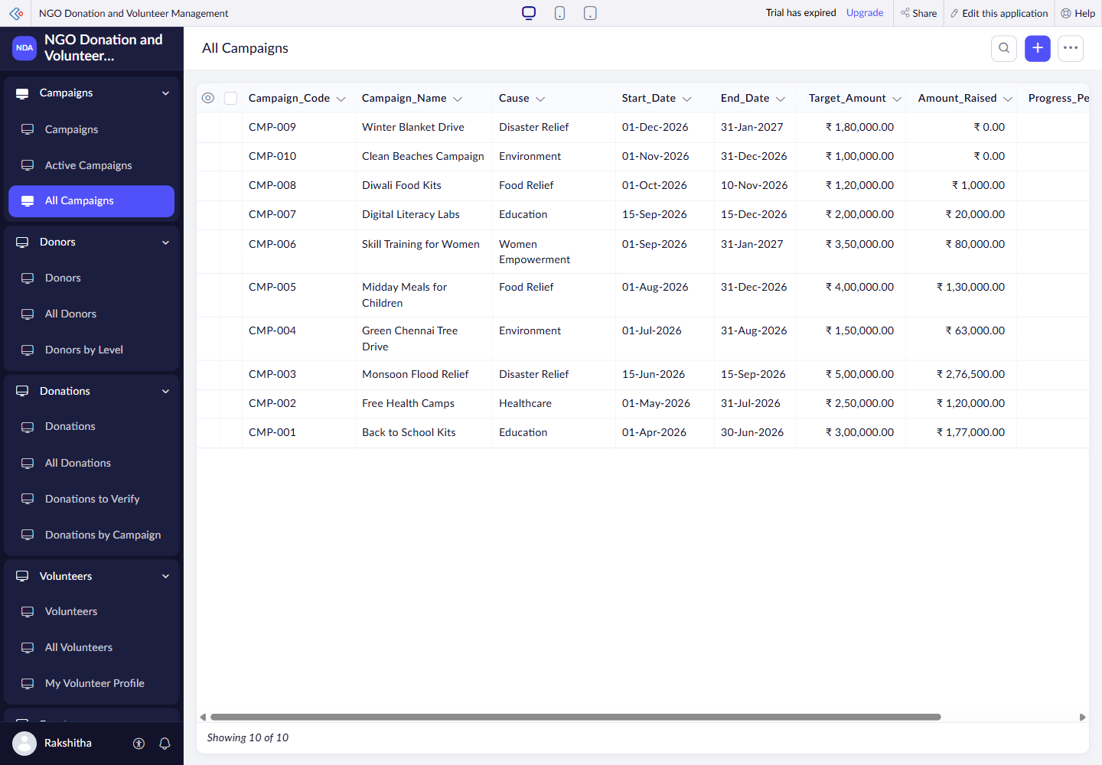
Figure 5.1: Live Navigation and Campaign Records

5.2 Forms and Data Capture
Campaigns stores fundraising targets and dates. Donors holds contact and classification details. Donations links each payment to a donor and campaign. Volunteers records skills and availability. Events contains the Volunteer Assignments subform. Required and unique fields are defined in YAML; on-load and validation scripts specify defaults and conditional behaviour.
The child-row design follows Creator’s SubForm model [2]. Criteria-based record selection [3] supports the source calculations. Source file locations are listed in Appendix C [6].

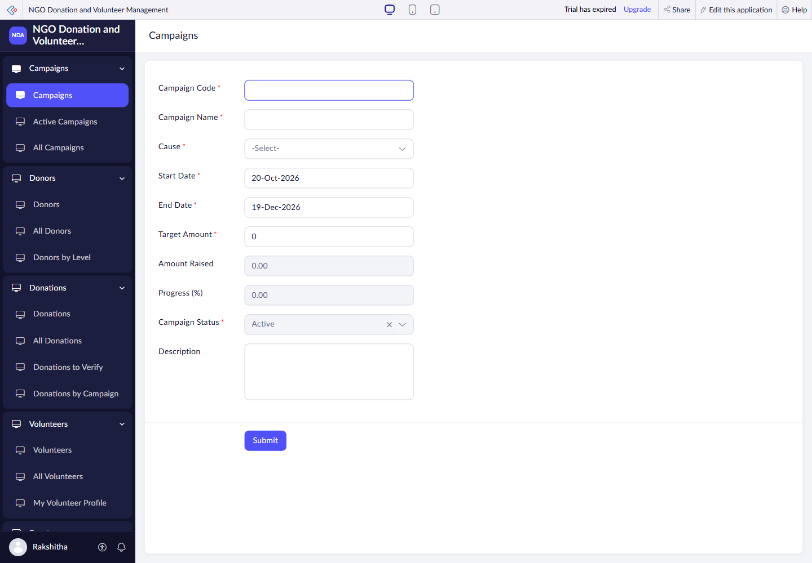
Figure 5.2: Campaigns Form in Live Mode

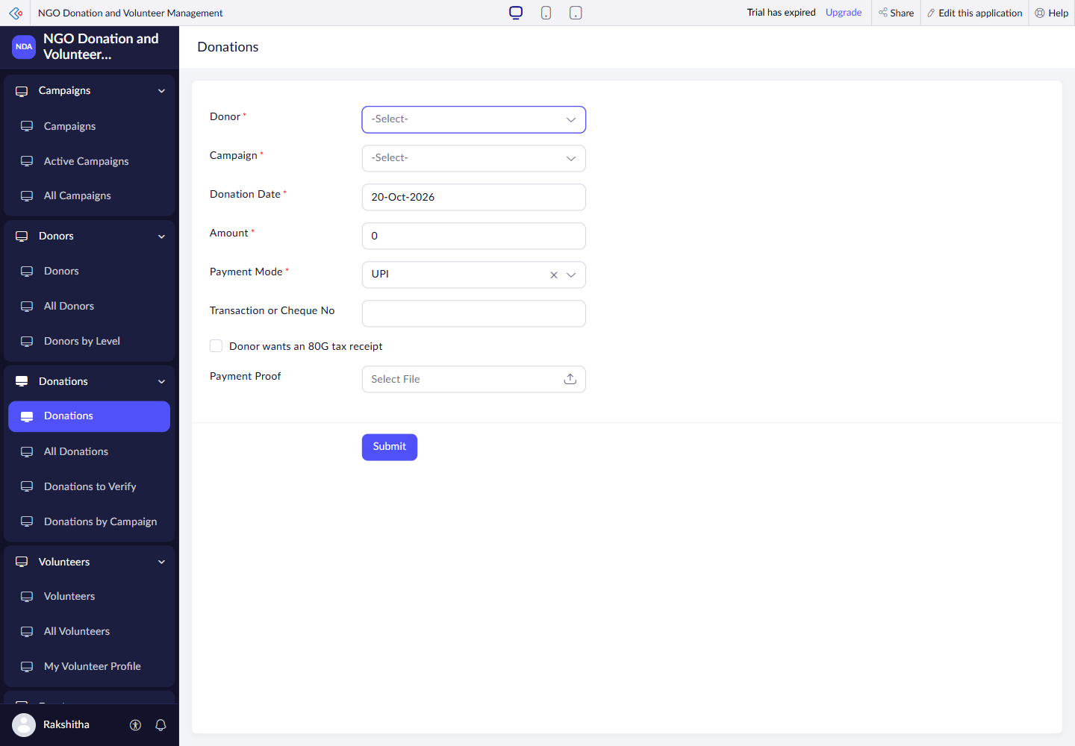
Figure 5.3: Donations Form in Live Mode
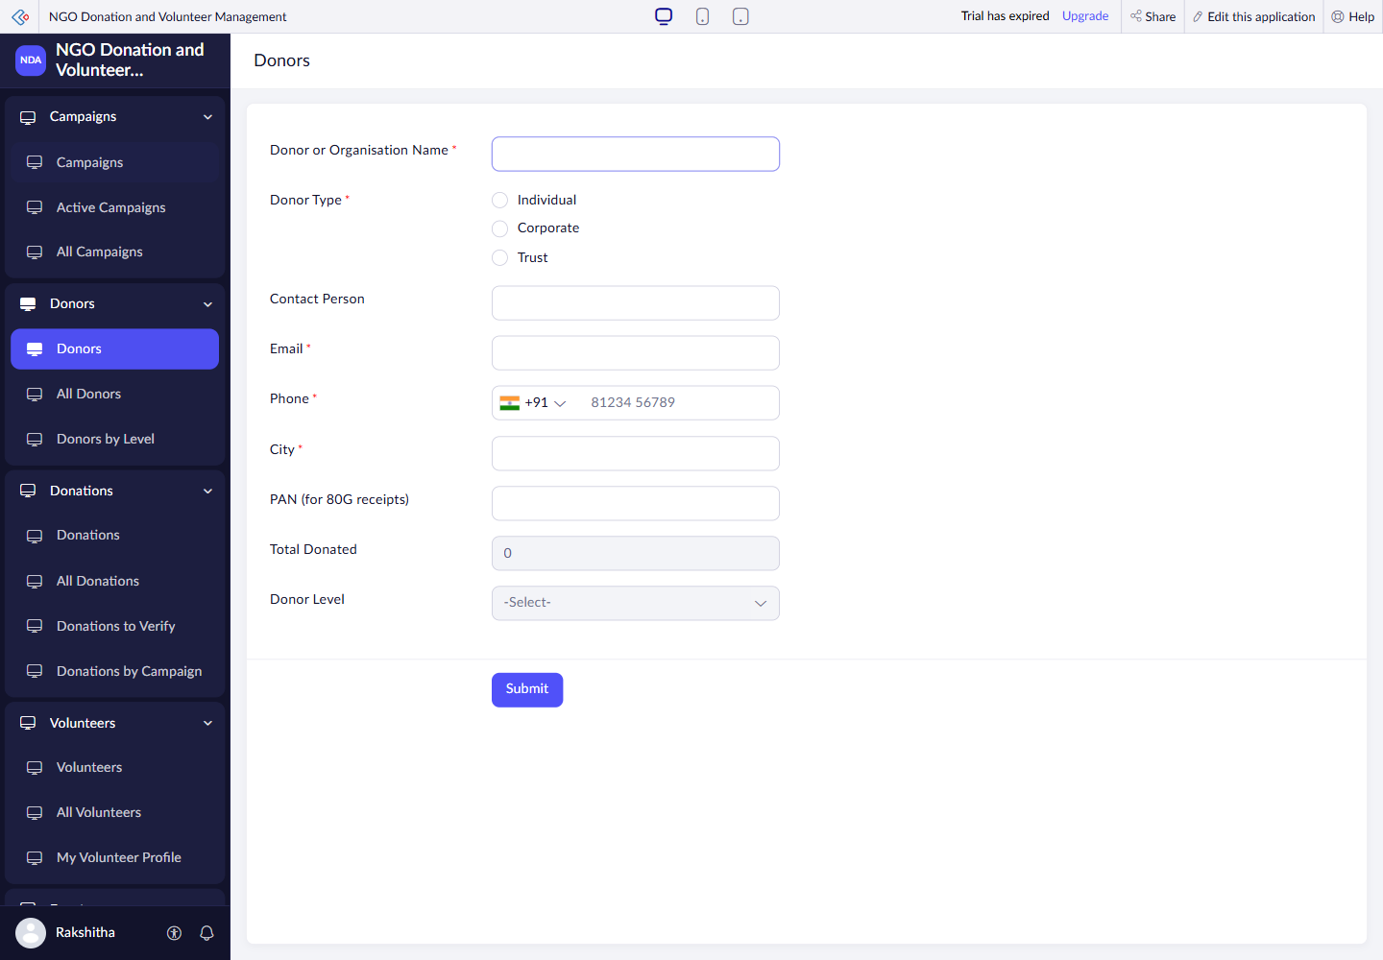
Figure 5.4: Donors Form in Live Mode
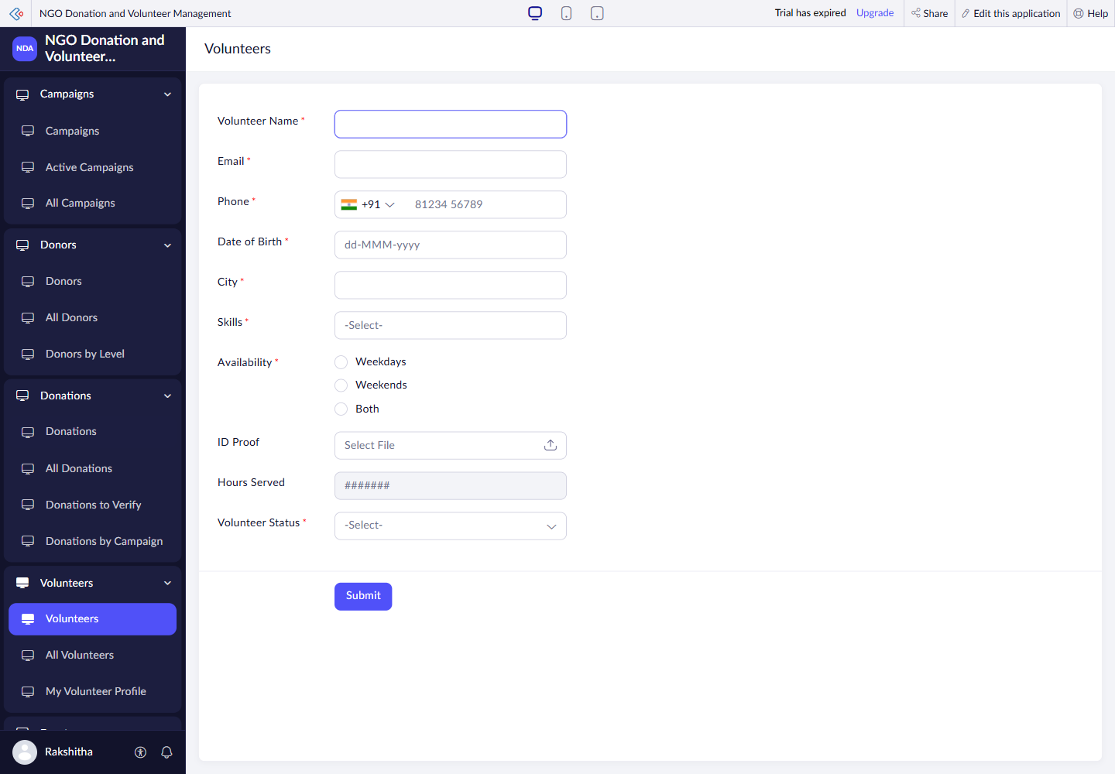
Figure 5.5: Volunteers Form in Live Mode
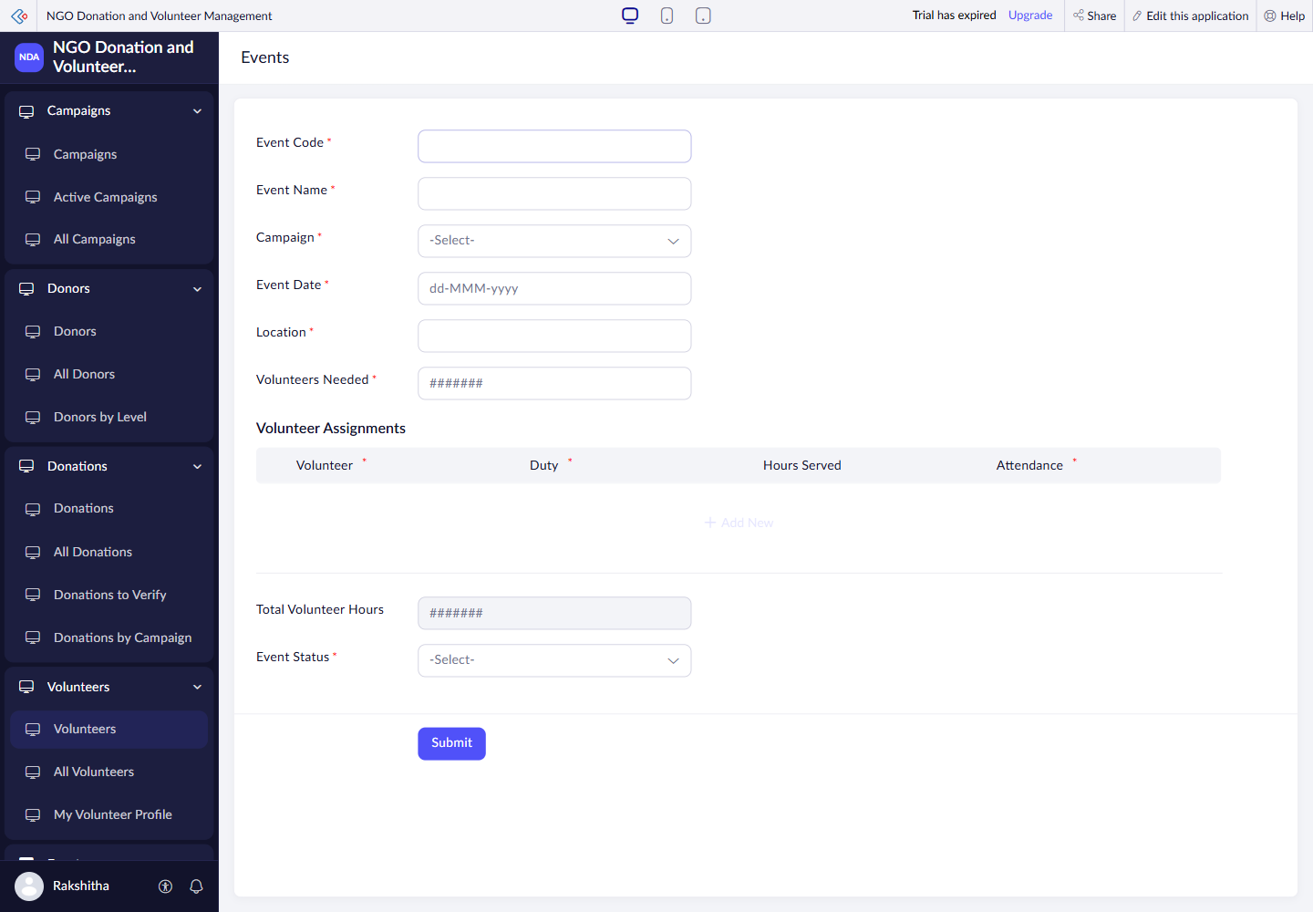
Figure 5.6: Events Form in Live Mode

5.3 Reports
Table 5.1: Reports Implemented
Report | Type | Source | Filter and sort | Custom actions | Access
Active Campaigns | List | Campaigns | Campaign_Status == "Active"; End_Date asc | None | Per profile matrix
All Campaigns | List | Campaigns | All records; Start_Date desc | None | Per profile matrix
All Donations | List | Donations | All records; Donation_Date desc | None | Per profile matrix
All Donors | List | Donors | All records; Donor_Name asc | None | Per profile matrix
All Events | List | Events | All records; Event_Date desc | None | Per profile matrix
All Volunteers | List | Volunteers | All records; Volunteer_Name asc | None | Per profile matrix
Donations by Campaign | Summary | Donations | Donation_Status == "Verified"; Campaign asc, Amount desc | None | Per profile matrix
Donations to Verify | List | Donations | Donation_Status == "Pending Verification"; Donation_Date asc | None | Per profile matrix
Donors by Level | Summary | Donors | All records; Donor_Level asc, Total_Donated desc | None | Per profile matrix
Event Board | Kanban | Events | Group by Event_Status; Event_Date asc | None | Per profile matrix
My Volunteer Profile | List | Volunteers | Email == zoho.loginuserid; | None | Per profile matrix
Upcoming Events | List | Events | Event_Status == "Scheduled"; Event_Date asc | None | Per profile matrix

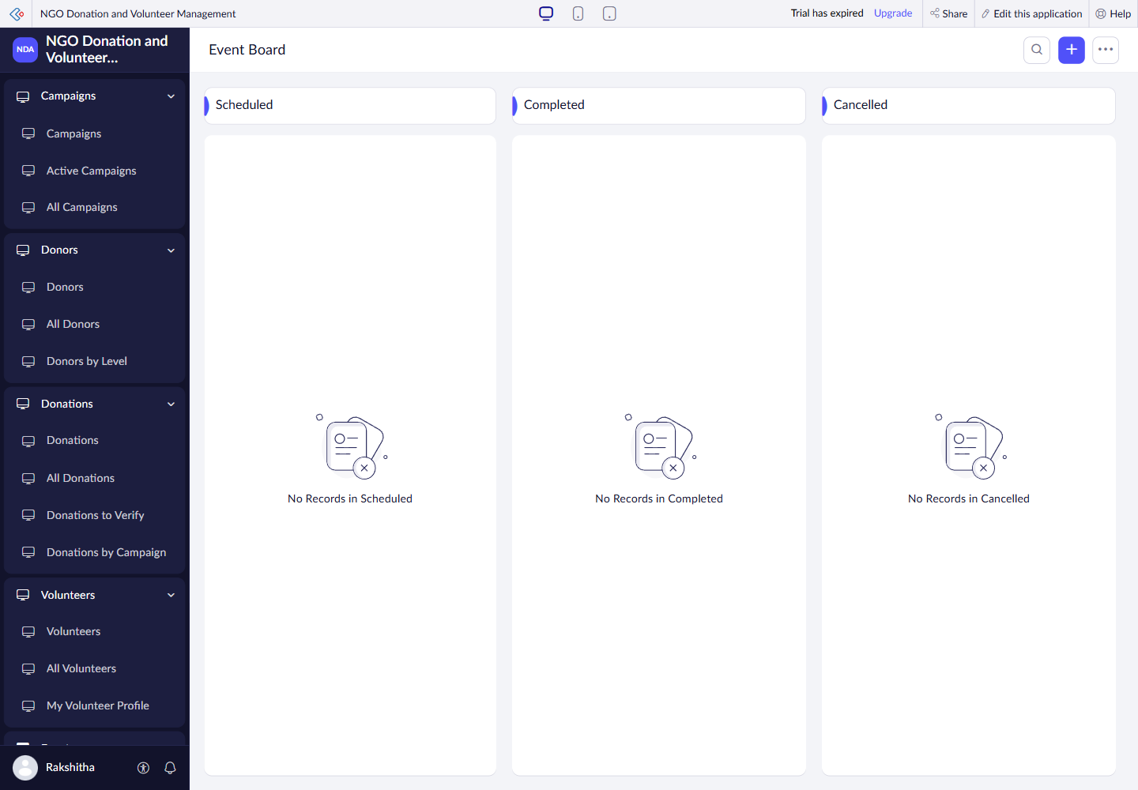
Figure 5.7: Event Board with No Current Records

5.4 Pages and Dashboards
The Dashboard serves the administrator and coordinator. Six indicators show verified funds, active campaigns, pending donations, active volunteers, upcoming events and beneficiaries. Four charts summarise causes, payment modes, donor levels and event status. Four buttons open forms, and two embedded reports show pending donations and upcoming events.

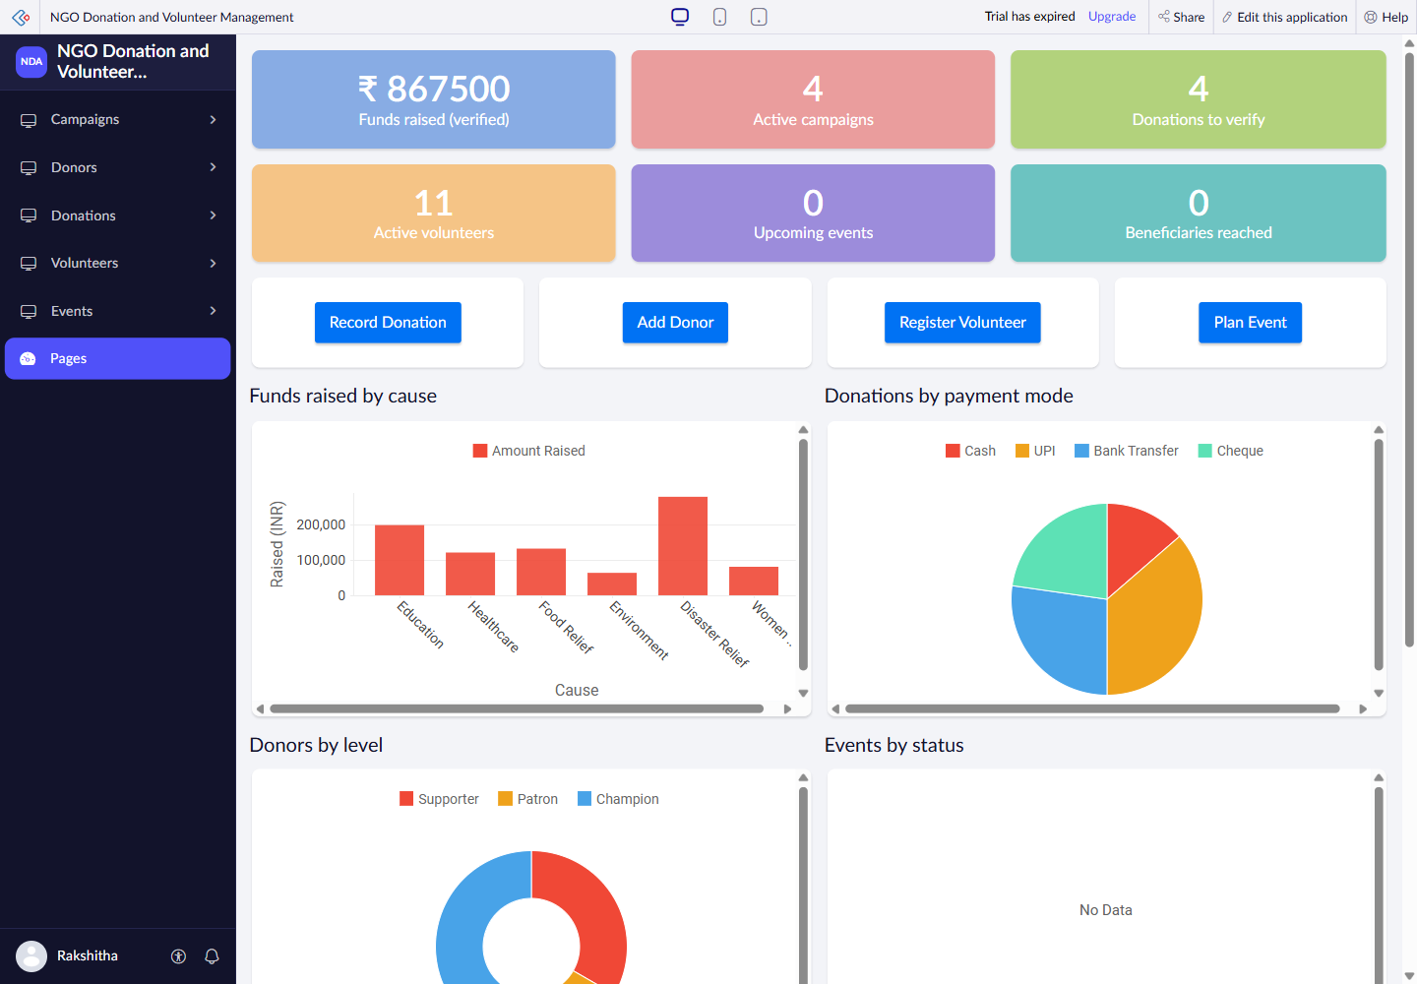
Figure 5.8: Live Donation and Volunteer Dashboard

5.5 Deluge Scripting
Table 5.2: Deluge Scripts Implemented
Script Group | Trigger | Purpose | Concepts
Campaign and donor rules | Load; validate | Defaults, dates and duplicate checks | Conditions; criteria
Donation rules | Load; input; validate; success | Payment checks; decision email; totals | Fetch; cancel submit; sendmail
Volunteer rules | Load; validate | Defaults, age and duplicate checks | Dates; criteria
Event rules | Load; input; validate; success | Assignments, attendance and hours | Subform loops; validation
3 reusable functions | After successful save | Recount campaign, donor and hours | Sum; fetch; loops
Daily_NGO_Check | Daily 09:00 IST | Campaign status; reminders; summary | Criteria; updates; sendmail

Code 5.1 Donation amount validation excerpt
// Donation_Validate excerpt
if(input.Amount == null || input.Amount < 1)
{
error = "The donation amount must be at least Rs. 1.";
}
else if(input.Amount > 1000000)
{
error = "A single donation cannot be more than Rs. 10,00,000.";
}

Code 5.2 Campaign total recalculation excerpt
// refreshCampaign excerpt; full routine in Appendix C
raised = ifnull(Donations[Campaign == campaignId && Donation_Status == "Verified"].sum(Amount),0);
campaign.Amount_Raised = raised;
campaign.Progress_Percent = (raised * 100 / campaign.Target_Amount).round(1);

Validation scripts use criteria fetches, conditions, alerts and cancel submit. Reusable functions recalculate totals from matching records. The current dashboard agrees with verified donation records; this does not establish that every source-defined workflow executed in the live app.

5.6 Workflows and Automation
Table 5.3: Workflows Implemented
Workflow Group | Type | Trigger | Condition | Action | Source
Campaign rules (2) | Form | Load; validate | Add / edit | Defaults; dates; status | Campaign_*
Donor rules (3) | Form | Load; input; validate | Add / edit | Contact visibility; duplicates | Donor_*
Donation rules (5) | Form | Load; input; validate; success | Add / edit | Validation; decision; totals; email | Donation_*
Volunteer rules (2) | Form | Load; validate | Add / edit | Defaults; age; duplicates | Volunteer_*
Event rules (4) | Form | Load; input; validate; success | Add / edit | Attendance and hour rules | Event_*
Daily campaign / event check | Schedule | 09:00 IST daily | From 21 Oct 2026 in source | Status updates and reminders | Daily_NGO_Check

Donation verification is a scripted status decision, not a demonstrated native Approval process or Blueprint. The source schedule starts on 21 October 2026 at 09:00 IST; execution was not observed.

5.7 Integrations
Table 5.4: Integrations Implemented
Integration | Service | Method | Authentication | Purpose
Development tooling | Creator API v2.1 [5] | External CLI | OAuth 2.0 | Metadata and record operations
Notifications | Creator sendmail [4] | Deluge task | zoho.adminuserid | Receipts and reminders; delivery pending
Business services | No external connector | Not configured | Not applicable | Payment and accounting integration deferred

Code 5.3 Simplified receipt notification
// Donation_Decision excerpt; executes on status transition
sendmail
[
from :zoho.adminuserid
to :donor.Email
subject :"Donation receipt " + input.Receipt_No + " - " + campaign.Campaign_Name
message :"Thank you for your donation."
]

No external business-service connection or Postman test was configured. Notification code is reviewed source; delivery is unverified.

5.8 User Management and Role-Based Access
The role hierarchy is CEO → Coordinator → Volunteer. The Administrator profile has full access; Coordinator maintains operational data but cannot edit donations. Volunteer is designed to register and read Active Campaigns, Upcoming Events and an own-profile report filtered by login email. Separate-profile sessions were not exercised.

The intended permissions are summarised in Table 4.8. User invitations and separate-profile login checks were not performed.

5.9 AI and Analytics Features
The live dashboard renders column, pie and donut charts from stored data. Events by Status has no data because Events is empty. AI assistance supported application and report preparation; no in-app Zia model or Zoho Analytics integration was demonstrated.

5.10 Pro-Code Extension
The external TypeScript CLI compiles YAML and Deluge definitions to an importable Creator application and supports API tooling. It is a development aid outside the end-user interface. No Catalyst service or custom JavaScript widget was deployed.

5.11 Mobile and Portal Access

Mobile and portal access were not demonstrated. The browser application is the verified access channel.
CHAPTER 6

TESTING AND DEBUGGING

6.1 Testing Strategy
Read-only browser checks covered record counts, dashboard values, reports and form layouts. Local scripts were reviewed for validation and automation. Negative submissions, email delivery, scheduled execution, separate-role access and user acceptance tests remain pending; planned tests are labelled accordingly.

6.2 Test Cases
Table 6.1: Test Cases
TC ID | FR | Check | Steps | Expected | Actual | Status
TC-01 | FR-01 | Campaign report | Open All Campaigns | 10 records | 10 observed | Pass
TC-02 | FR-01 | Donor report | Open All Donors | 12 records | 12 observed | Pass
TC-03 | FR-02 | Donation report | Open All Donations | 22 records | 22 observed | Pass
TC-04 | FR-03 | Verified records | Open verified summary | 17 verified | 17 observed | Pass
TC-05 | FR-03 | Pending queue | Open Donations to Verify | 4 pending | 4 observed | Pass
TC-06 | FR-03 | Fund total | Compare verified rows and dashboard | INR 867500 | INR 867500 | Pass
TC-07 | FR-04 | Volunteer report | Open All Volunteers | 12; 11 active | 12; 11 active | Pass
TC-08 | FR-06 | Active campaigns | Inspect campaign statuses | 4 Active | 4 observed | Pass
TC-09 | FR-05 | Event dataset | Open All Events | Event examples available | 0 live records | Gap
TC-10 | FR-05 | Assignment layout | Open Events form | Subform visible | Fields visible; save untested | Partial
TC-11 | FR-02 | Invalid amount | Submit zero or excessive amount | Reject | Source reviewed only | Pending
TC-12 | FR-02 | Payment reference | Non-cash without reference | Reject | Source reviewed only | Pending
TC-13 | FR-02 | Duplicate transaction | Reuse existing reference | Reject | Source reviewed only | Pending
TC-14 | FR-04 | Underage volunteer | Age below 18 | Reject | Source reviewed only | Pending
TC-15 | FR-05 | Invalid assignment | Inactive or duplicate volunteer | Reject | Source reviewed only | Pending
TC-16 | FR-03 | Decision notification | Verify a pending donation | Totals update; receipt delivered | No edit or email test | Pending
TC-17 | FR-07 | Daily execution | Observe after scheduled start | Status / reminder actions | Not observed | Pending
TC-18 | FR-08 | Profile isolation | Separate Volunteer login | Only permitted own data | Not exercised | Pending

6.3 Debugging Deluge Scripts
The browser was used to inspect rendered forms and reports, and local source definitions were compared with their visible outputs. No Deluge execution log was collected. The empty Events report is a verified data gap; its cause was not established.

The All Events report displayed “There are no records in this report.” No submission or workflow execution log was collected.

6.4 Defect Log
Table 6.2: Defect Log
ID | Issue | Cause | Next action | Status
D-01 | Events report empty | Not established | Populate and test event journey | Open
D-02 | Source README says 15 form workflows | 16 files present | Use source inventory count | Corrected in report
D-03 | Local owner differs from live owner | Saved project target is older | Use verified Rakshitha live URL | Documented

6.5 User Acceptance Testing
Table 6.3: User Acceptance Feedback
User | Role | Feedback | Action
Not yet recorded | Coordinator | Real user session pending | Review donation workflow
Not yet recorded | Volunteer | Real user session pending | Review registration and activity access
CHAPTER 7

DEPLOYMENT, SECURITY AND GOVERNANCE

7.1 Environments and Deployment Strategy
The authenticated live application was opened in Rakshitha’s Creator account on 20 October 2026. The inspection confirms current access and populated reports. A Development → Stage → Production promotion and rollback exercise was not recorded. Exported application definitions should be retained before future changes.

The live URL was verified. Cross-environment promotion and publication history were not inspected.
Table 7.1: Deployment Checklist
No. | Deployment item | Status
1 | Live app and owner verified | Done
2 | Campaign, donor, donation and volunteer data | Observed
3 | Event sample data and full journey | Pending
4 | Profile login checks | Pending
5 | Schedule and email execution | Pending
6 | Development / Stage / Production promotion | Not recorded
7 | Export and rollback exercise | Pending

7.2 Performance Optimisation
Table 7.2: Performance Optimisation Results
Technique | Component | Before | After | Measurement
Criteria-based sum | Verified donation totals | No benchmark | Targeted sum in source | No latency claim
Filtered views | Pending / active reports | No benchmark | Relevant subsets | 4 pending rows observed
Lookups | Donation forms | Repeated entry baseline | Reuse donor and campaign | Time saving not measured

7.3 Security Features
Table 7.3: Security Controls Implemented
Control | Location | Purpose and limit
Profile restrictions | Permission YAML | Coordinator cannot edit donations; role test pending
Own-profile criteria | My Volunteer Profile | Email == zoho.loginuserid; separate login pending
Authenticated session | Live browser app | Owner access verified
OAuth tooling | External CLI config | Credentials excluded from report
Sensitive data handling | PAN and proof uploads | Restrict staff access; encryption not verified

7.4 Governance and Administration
Keep YAML, Deluge and sample datasets under version control, use consistent link names, and export the app before structural changes. The administrator should review access, credentials, schedules and report accuracy. A native audit-trail event and restore exercise remain to be verified.

Source definitions and browser evidence are retained. No native audit-trail event is claimed.
CHAPTER 8

RESULTS AND DISCUSSION

8.1 Application Output
The current donation journey can be inspected without adding records: open All Campaigns, follow a donor-linked payment in All Donations, then compare Donations to Verify with the dashboard. Seventeen verified payments contribute to the total. Event allocation and attendance remain a configured follow-on journey because the live Events dataset is empty.

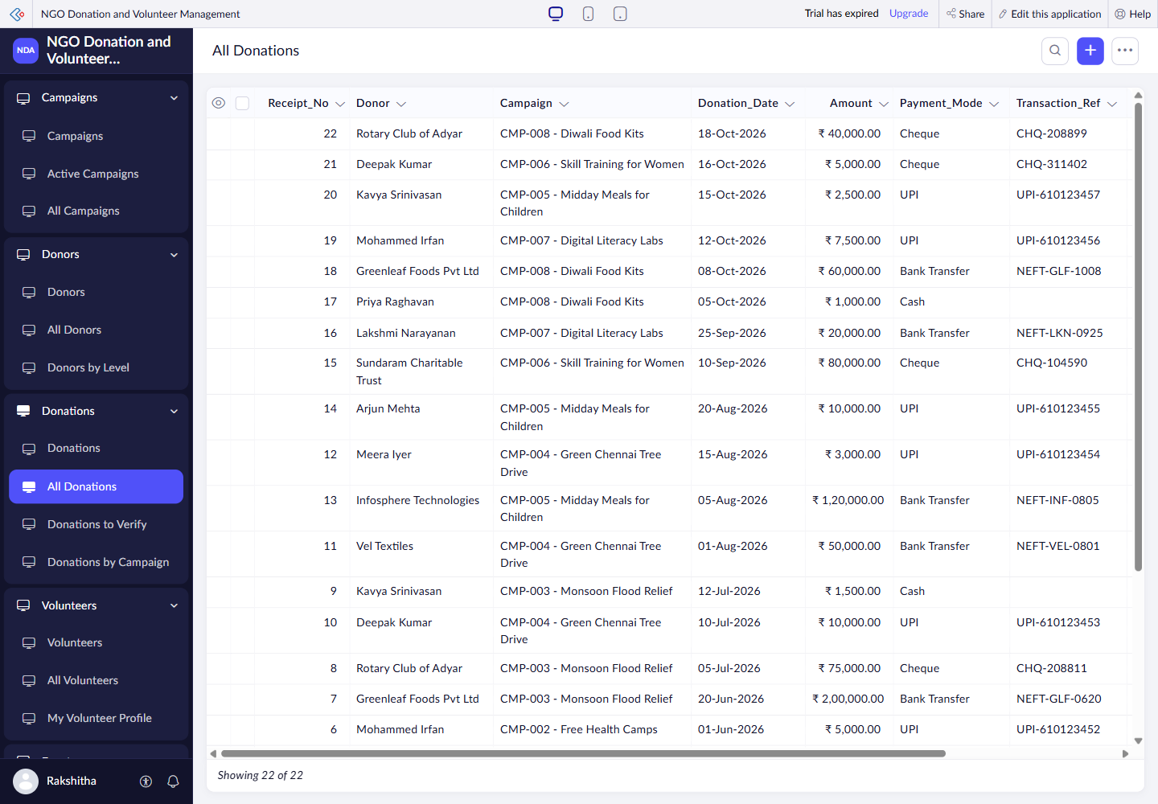
Figure 8.1: Donation Records and Current Statuses

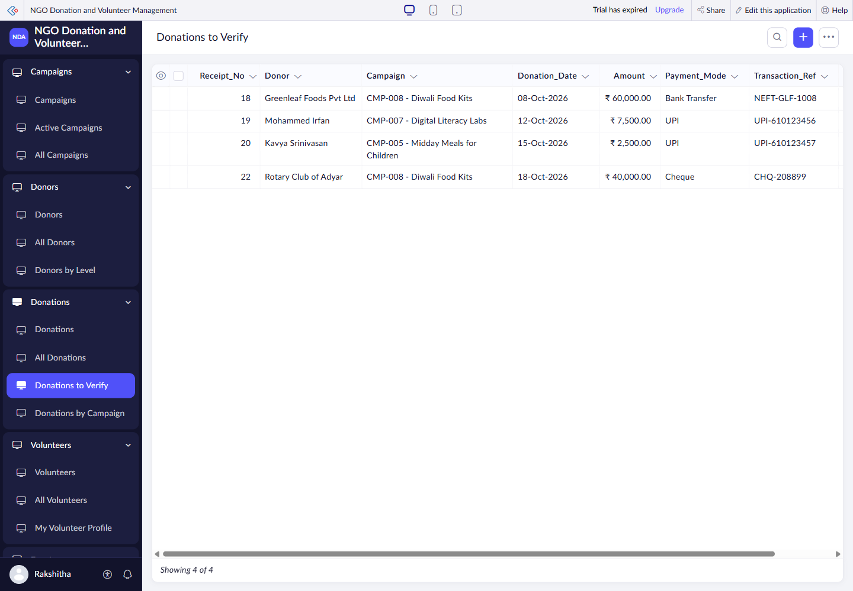
Figure 8.2: Treasurer Queue with Four Pending Donations

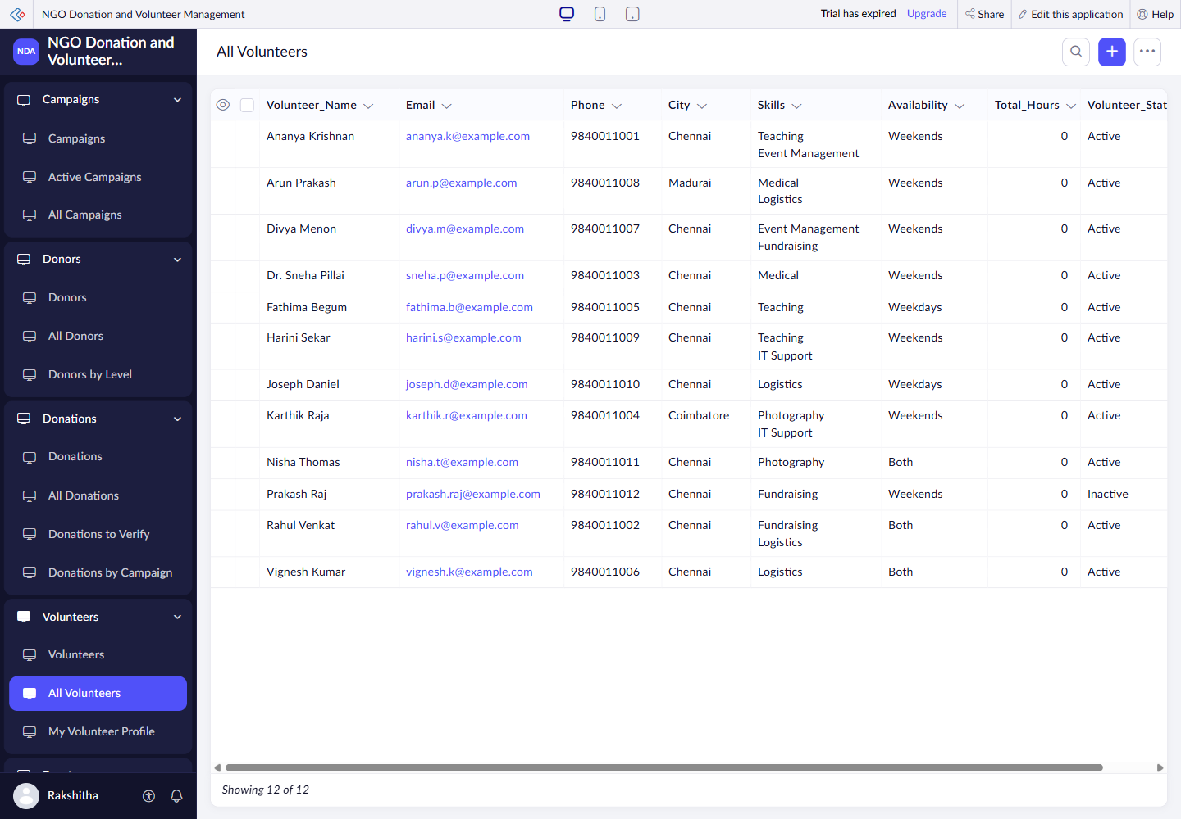
Figure 8.3: Volunteer Register with Twelve Records

8.2 Achievement of Objectives
Table 8.1: Mapping of Objectives to Outcomes
Objective | Implementation | Outcome
Related NGO records | Five forms and lookups | Four populated datasets observed
Payment oversight | Status reports and totals | 17 verified; 4 pending; 1 rejected
Volunteer coordination | Register and event subform | 12 volunteers; event journey pending
Operational visibility | 12 reports and Dashboard | Live counters and charts rendered
Controlled access | Three profiles | Source-defined; separate-role test pending

8.3 Comparison with the Existing System
Table 8.2: Existing System versus Proposed Application
Parameter | Manual baseline | Application | Result
Data capture | Repeated spreadsheet entry | Related forms and lookups | Shared references
Verification | Separate treasurer list | Pending donation report | 4 entries visible
Totals | Manual addition | Verified total and campaign progress | INR 867500 observed
Volunteer activity | Messages and attendance sheets | Events and assignment rows | Configured; no live events

8.4 Limitations of the Low-Code Approach
Creator controls report layouts, field behaviour and available features through its platform and subscription. The live account showed an expired trial, but its effect on event saving was not tested. Complex external accounting and payment processing would need additional integration work. Source definitions alone do not prove live permission enforcement.

8.5 Reflection on the No-Code → Low-Code → Pro-Code Spectrum
Forms, field types and report layouts are no-code configuration. Validation, totals and notification rules use low-code Deluge. The external TypeScript CLI is pro-code tooling for repeatable generation and deployment. A custom service would be appropriate if reconciliation or reporting exceeded platform capabilities.
CHAPTER 9

CONCLUSION AND FUTURE ENHANCEMENTS

9.1 Conclusion
The project brings campaigns, donors, donations, volunteers and event planning into one Creator application. The inspected dataset demonstrated connected records, donation status reporting and a dashboard showing INR 867500 in verified funds. Event participation, notification delivery and separate-role behaviour remain to be demonstrated before a complete operational evaluation.

9.2 Future Enhancements
- Complete event records and verify attendance, hours and beneficiary totals.
- Add payment reconciliation and accounting integration after defining approval and security requirements.
- Complete role-based tests, notification checks and user feedback; add donor or volunteer self-service if needed.

9.3 Learning Outcomes and Career Relevance
The project develops skills in data modelling, form design, Deluge validation, reporting and evidence-based verification. These skills support low-code developer and automation roles. Reviewing generated source and distinguishing configured behaviour from observed results are essential parts of that work.

REFERENCES
[1] Zoho Corporation, “Zoho Creator Features.” Available: https://www.zoho.com/creator/features/ (accessed 20 October 2026).
[2] Zoho Corporation, “Understand SubForm Field.” Available: https://help.zoho.com/portal/en/kb/creator/developer-guide/forms/add-and-manage-fields/articles/fields-subform-understand (accessed 20 October 2026).
[3] Zoho Corporation, “Fetch records.” Available: https://www.zoho.com/deluge/help/fetch-records/fetch-collection-records.html (accessed 20 October 2026).
[4] Zoho Corporation, “Send mail.” Available: https://www.zoho.com/deluge/help/misc-statements/send-mail.html (accessed 20 October 2026).
[5] Zoho Corporation, “Overview — Creator API v2.1.” Available: https://www.zoho.com/creator/help/api/v2.1/ (accessed 20 October 2026).
[6] Project source, “NGO Donation and Volunteer Management,” apps/ngo-management, YAML and Deluge definitions, local snapshot, 20 October 2026.

APPENDIX A – ZOHO CREATOR FEATURE COVERAGE CHECKLIST
Table A.1: Feature Coverage Checklist
Unit | Zoho Creator Feature | Done | Where in the Application | Report Section | Figure / Code No.
I | Application created & sections/menu organised | Y | Six navigation sections | 5.1 | Fig5.1
II | Forms with ≥ 8 distinct field types | Y | 16 distinct source field types | 5.2 | Tables4.2–4.7
II | Lookup field (relationship between forms) | Y | Donor, Campaign, Volunteer | 4.2 | Fig4.2
II | Subform (parent–child data) | Partial | Assignments visible; save untested | 5.2 | Fig5.6
II | Field validations / layout rules | Partial | Source rules; negative tests pending | 5.2 | Code5.1
II | List report with filter, grouping, custom action | Partial | Filtered lists; no custom action | 5.3 | Table5.1
II | Kanban / Calendar / Timeline / Map report | Y | Event Board; empty dataset | 5.3 | Fig5.7
II | Pivot table / chart report | N | Summary views; no pivot report | 5.3 | Table5.1
II | Page / dashboard built with UI Builder | Y | Live Dashboard | 5.4 | Fig5.8
II | Deluge – form events (validate / success / field actions) | Partial | Source events; runtime tests pending | 5.5 | AppendixC
II | Deluge – functions, fetch, loops, collections | Y | 3 source functions | 5.5 | AppendixC
II | Email / in-app notifications | Partial | sendmail defined; delivery untested | 5.6 | Code5.3
II | Form workflow | Y | 16 source form workflows | 5.6 | Table5.3
II | Scheduled workflow | Partial | Daily09:00; starts21Oct2026 | 5.6 | Table5.3
II | Approval process | Partial | Scripted decisions; no native approval | 5.6 | Fig4.3
II | Blueprint | N | No Blueprint | 5.6 | Not used
II | Batch / report workflow | N | No batch / report workflow | 5.6 | Not used
II | Testing & debugging evidence | Y | Read-only browser checks | 6 | Table6.1
III | Integration with a Zoho service | N | No separate Zoho connector | 5.7 | Table5.4
III | Connection / REST API call (invokeurl) | N | No Deluge invokeurl connection | 5.7 | Table5.4
III | Webhook or Creator REST API | Partial | External CLI API tooling; no live API test | 5.7 | Table5.4
III | Users, roles and permission profiles | Partial | Roles / profiles in source | 5.8 | Table4.8
III | Record-level access criteria / customer portal | Partial | Own-profile criteria; no portal | 5.8 | Section5.8
III | Zia / AI feature | N | External AI assistance; no Zia | 5.9 | Section5.9
III | Analytics (charts / Zoho Analytics) | Y | Dashboard charts | 5.9 | Fig5.8
IV | Performance optimisation applied & measured | N | No measured benchmark | 7.2 | Table7.2
IV | Deployment across environments | N | No staged promotion evidence | 7.1 | Table7.1
IV | Security controls (encryption, OAuth, permissions) | Partial | Source profiles and authenticated access | 7.3 | Table7.3
IV | Governance (audit trail, administration) | Partial | Versioned definitions; audit pending | 7.4 | Section7.4
V | Pro-code extension (Catalyst / widgets / custom functions) | Y | External TypeScript CLI | 5.10 | Section5.10
V | Low-code limitations & spectrum analysis | Y | Platform limits discussed | 8.4 | Section8.5
— | Mobile app / portal access | N | No mobile / portal demonstration | 5.11 | Not verified

Coverage: 11 evidenced, 12 partial and 9 absent or unverified items out of 32. Source-only rules are not treated as completed runtime tests.

APPENDIX B – COURSE OUTCOME MAPPING
Table B.1: Mapping of Course Outcomes to Report Chapters
CO | Course Outcome Statement | Evidenced In | Self-Assessed Level | Examiner Level
CO1 | Explain the principles, architecture, and business value of low-code application development using Zoho Creator. | Ch. 1, 2 | 2
CO2 | Develop business applications using Zoho Creator forms, reports, workflows, and Deluge scripting. | Ch. 4, 5 (5.1–5.6), 6 | 2
CO3 | Integrate Zoho Creator applications with Zoho services and external systems using APIs, connections, and role-based security. | Ch. 4.6, 5.7–5.9 | 1
CO4 | Deploy, secure, and manage Zoho Creator applications across development and production environments following governance best practices. | Ch. 7 | 1
CO5 | Evaluate low-code development strategies, AI-assisted application development, and the transition from citizen developer to professional developer. | Ch. 5.9, 5.10, 8.4, 8.5, 9.3 | 2

APPENDIX C DELUGE SOURCE ROUTINES
C.1 Campaign total recalculation
The following complete routines illustrate the two main calculations. Full validation, notification and schedule files are retained in apps/ngo-management [6].
void refreshCampaign(int campaignId)
{
// Totals a campaign's verified donations into Amount Raised and Progress (%). It recounts
// rather than adding or subtracting, so the total can't drift. Called after a donation is saved.
campaign = Campaigns[ID == campaignId];
if(campaign.count() > 0)
{
raised = ifnull(Donations[Campaign == campaignId && Donation_Status == "Verified"].sum(Amount),0);
campaign.Amount_Raised = raised;
campaign.Progress_Percent = (raised * 100 / campaign.Target_Amount).round(1);
}
}

C.2 Volunteer hour recalculation
void refreshVolunteerHours(int volunteerId)
{
// Adds up the hours a volunteer served at completed events where they were present,
// reading every event's Volunteer Assignments subform. Called after an event is saved.
vol = Volunteers[ID == volunteerId];
if(vol.count() > 0)
{
total = 0;
for each ev in Events[Event_Status == "Completed"]
{
for each row in ev.Assignments
{
if(row.Volunteer == volunteerId && row.Attendance == "Present")
{
total = total + ifnull(row.Hours_Served,0);
}
}
}
vol.Total_Hours = total;
}
}
C.3 Other reusable routine
refreshDonor.deluge
C.4 Form workflow source files
Campaign_Form_Load.deluge, Campaign_Validate.deluge, Donation_Decision.deluge, Donation_Form_Load.deluge, Donation_Mode_Changed.deluge, Donation_Saved.deluge, Donation_Validate.deluge, Donor_Form_Load.deluge, Donor_Type_Changed.deluge, Donor_Validate.deluge, Event_Form_Load.deluge, Event_Saved.deluge, Event_Status_Changed.deluge, Event_Validate.deluge, Volunteer_Form_Load.deluge, Volunteer_Validate.deluge
C.5 Daily schedule
Daily_NGO_Check.deluge

APPENDIX D – USER MANUAL

D.1 Accessing the Application
Sign in to the assigned Zoho account and open the live application URL in Project at a Glance. Use the side menu to select a form, report or Dashboard. The application requires assigned access; no password is included in this report.

D.2 Administrator and Coordinator
- Coordinator: create a campaign, add the donor, and record the payment with its campaign, amount and reference. Use Donations to Verify to track pending entries.
- Administrator: inspect payment evidence, edit Donation Status to Verified or Rejected, and provide a reason for rejection. Confirm the campaign and donor totals afterwards. Review notification delivery separately.

D.3 Volunteer and Event Operations
- Volunteer: register with contact details, skills and availability. Once access is assigned, use Active Campaigns, Upcoming Events and My Volunteer Profile.
- Coordinator: plan an event within the campaign period, add active volunteers once each, and assign duties. After the event, record attendance and hours before completing it with beneficiaries and an outcome. Verify the totals after saving.

APPENDIX E – EVALUATION RUBRIC
(For Examiner Use Only)
Student Name | Rakshitha RD | Register No. | 2116241501163
Project Title | NGO Donation and Volunteer Management | Date | ____________________

Table E.1: Evaluation Rubric for the Individual Project
S.No. | Criterion | Indicators | Max. Marks | Marks Awarded
1 | Problem Definition & Requirement Analysis | Clarity of problem, measurable objectives, complete FR/NFR, use cases | 10
2 | System Design | Architecture, ER/data model, form specifications, workflow design, permission matrix | 10
3 | Forms, Reports & Pages | Variety of field types, lookups/subforms, report types, UI Builder dashboards | 15
4 | Deluge Scripting & Workflows | Correctness and depth of scripts; form, schedule, approval, Blueprint, batch workflows | 15
5 | Integration, RBAC & AI | Zoho/external integrations, connections, roles & permissions, Zia/analytics | 10
6 | Testing, Deployment, Security & Governance | Test coverage, environments, optimisation, security controls, audit | 10
7 | Live Demonstration | End-to-end working of the application across roles; feature checklist verified | 15
8 | Project Report | Adherence to template and format, clarity, figures, references | 5
9 | Viva-Voce | Understanding of the platform, design decisions and low-code concepts | 10
 | TOTAL |  | 100

Table E.2: Performance Level Descriptors
Level | % of Max. Marks | Descriptor
Excellent | 90–100 | Feature implemented completely, correctly and beyond the basic requirement; student explains design choices confidently.
Good | 70–89 | Feature implemented correctly with minor gaps; explanation adequate.
Satisfactory | 50–69 | Feature partially implemented or works only for the main path; limited explanation.
Needs Improvement | < 50 | Feature missing, non-functional or not understood by the student.

Signature of Internal Examiner  Name: ____________________ | Signature of External Examiner  Name: ____________________

APPENDIX F – VIVA-VOCE RECORD SHEET
(For Examiner Use Only)
Student Name | Rakshitha RD | Register No. | 2116241501163
Department / Section | B.Tech AI and ML | Date of Viva | ____________________
Application URL Verified | Examiner to verify | Demo Duration | ______ min
Table F.1: Viva-Voce Questions and Responses
Q.No. | Question / Topic Asked | Unit | Response (E / G / S / NI) | Remarks
1
2
3
4
5
6
7
8
E – Excellent G – Good S – Satisfactory NI – Needs Improvement
Table F.2: Marks Summary
Component | Max. Marks | Marks Awarded
Criteria 1–8 (Appendix E) | 90
Viva-Voce | 10
TOTAL | 100
Examiners’ Remarks:
____________________________________________________________________
____________________________________________________________________
INTERNAL EXAMINER  Name: ____________________ | EXTERNAL EXAMINER  Name: ____________________

